User Manual

Program: movie_test.cpp

This program prompts the user for data relating to movies, and then prints that data to the console and to a file. It will ask for the title, director, rating, year, the IMDB url, and an actor. It will read the rest of the movies from a file with the name ‘Movie_setup_spp53.txt’. Once it has accepted these values, it takes them and outputs them as described above, to two sources. The filename that the output is sent to is called “example.txt” and can be found in the project folder.

To run the program double click on the file movie_test.exe, or open movie_test.cpp with Microsoft Visual Studio 2010 or above and hit Control F5. A console window will appear asking you to enter the movie’s title, director, rating, year, the IMDB url, and an actor. Please use only integers for the year, otherwise it will malfunction… The other data fields should accept any input. Hit enter after typing your input for each field. Repeat this process until finished with the prompts. Press any key to terminate the program when you are done.

System Manual

Program: movie_test.cpp

This program focuses on the construction and implementation of the Movie class. All the get methods acquire information about the class. The set methods allocate specific traits to the instance of the class called as an implicit. The output method translates Movie_Rating class to a string. It then outputs the various attributes of the class at the time at which it’s called. The constructor is set to allow to be created blank, with only a title, a copy constructor, and one that uses all aspects of the private section of the class. It includes a deconstructor for this class as well. There is also a second data type called Movie_Rating used above that is created using enum, and defines the various types of possible ratings for a movie. One of the movies is directly declare, another is created via user input, and the last three are read from a file. Other than that, the program runs as described in the user manual, though this is the implementation in the Movie.cpp class and the outline shown in the header file.

The user is expected not to use special characters that C++ will not recognize. They are also expected to enter a non-negative integer for the year. The year is declare as an integer so all decimal places will be truncated. The program malfunctions if you try to use anything but a number using 0-9 for the year and skips past all other commands…

Test Log

|  |
| --- |
| **Movie: Harold and Maude Director: Hal Ashby Year: 1971 Rating: R IMDB URL: http://www.imdb.com/title/tt0067185/** |

Example from the Homework

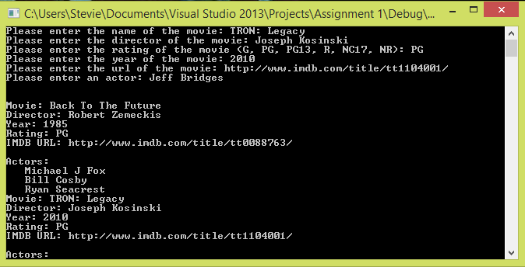

User Example of Movie Entry

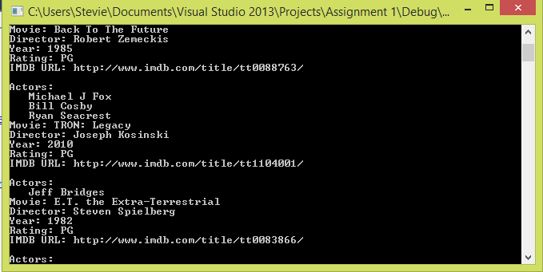

Example of Output to Screen

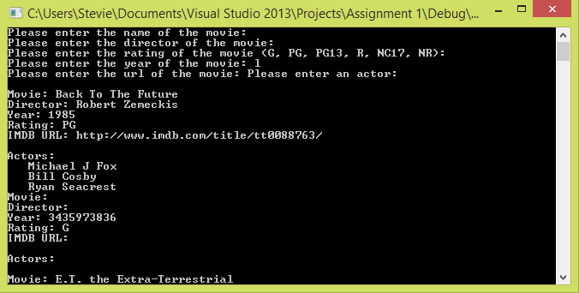

Example of entering a letter for year input. It shows how it skips commands.